# CLONE OF VM

**STEP – 1:**

Create a virtual machine.

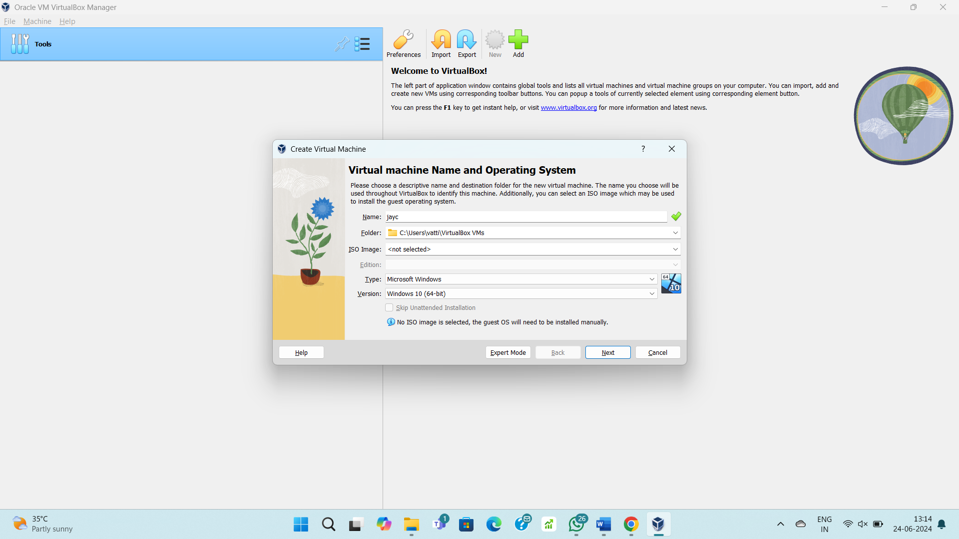

**STEP – 2:**

Allocate resources to the VM.

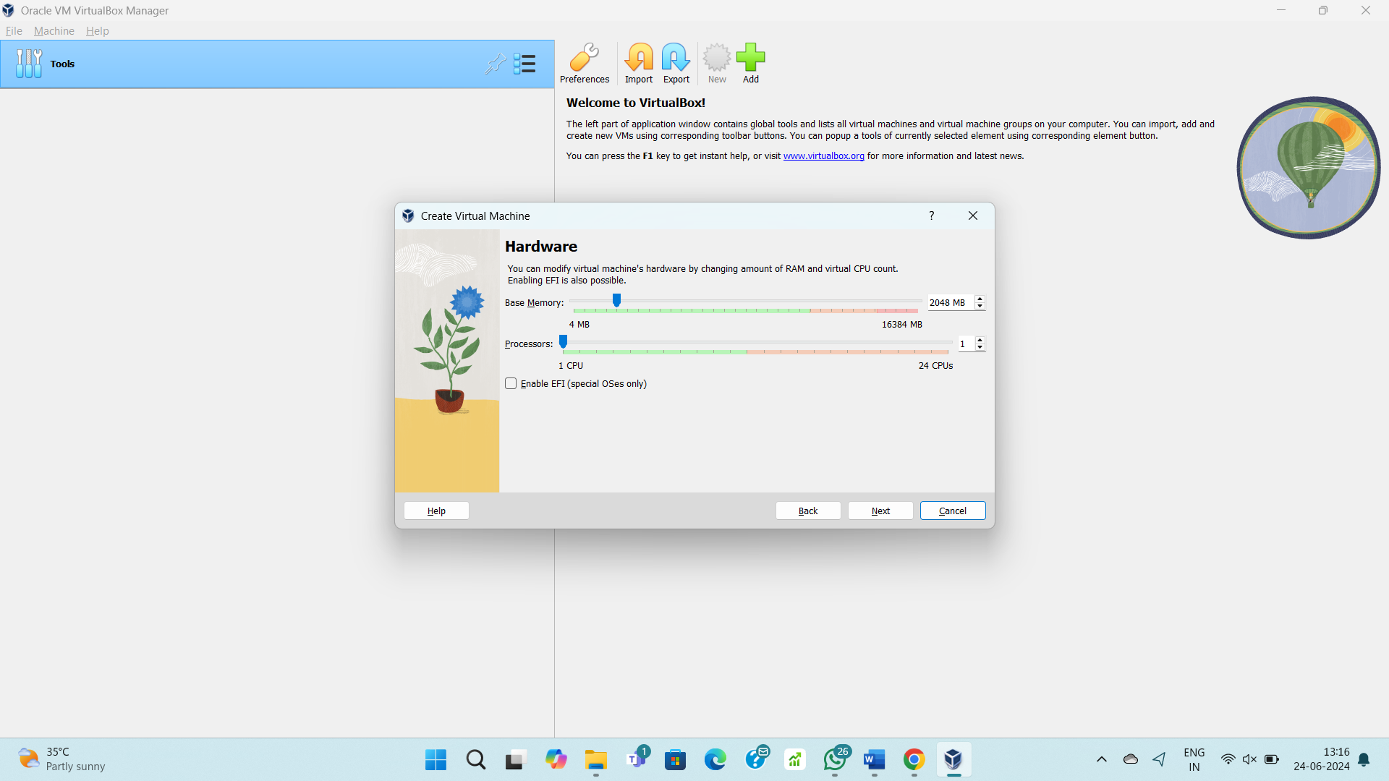

**STEP – 3:**

Allocate disk storage.

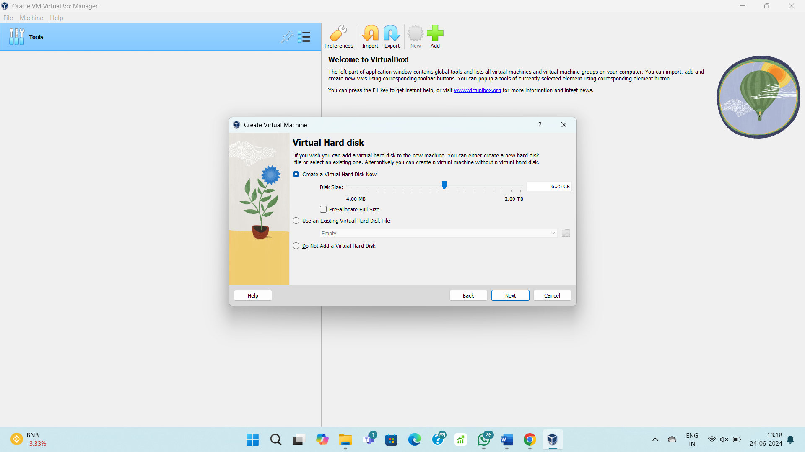

**STEP – 4:**

Created a VM.

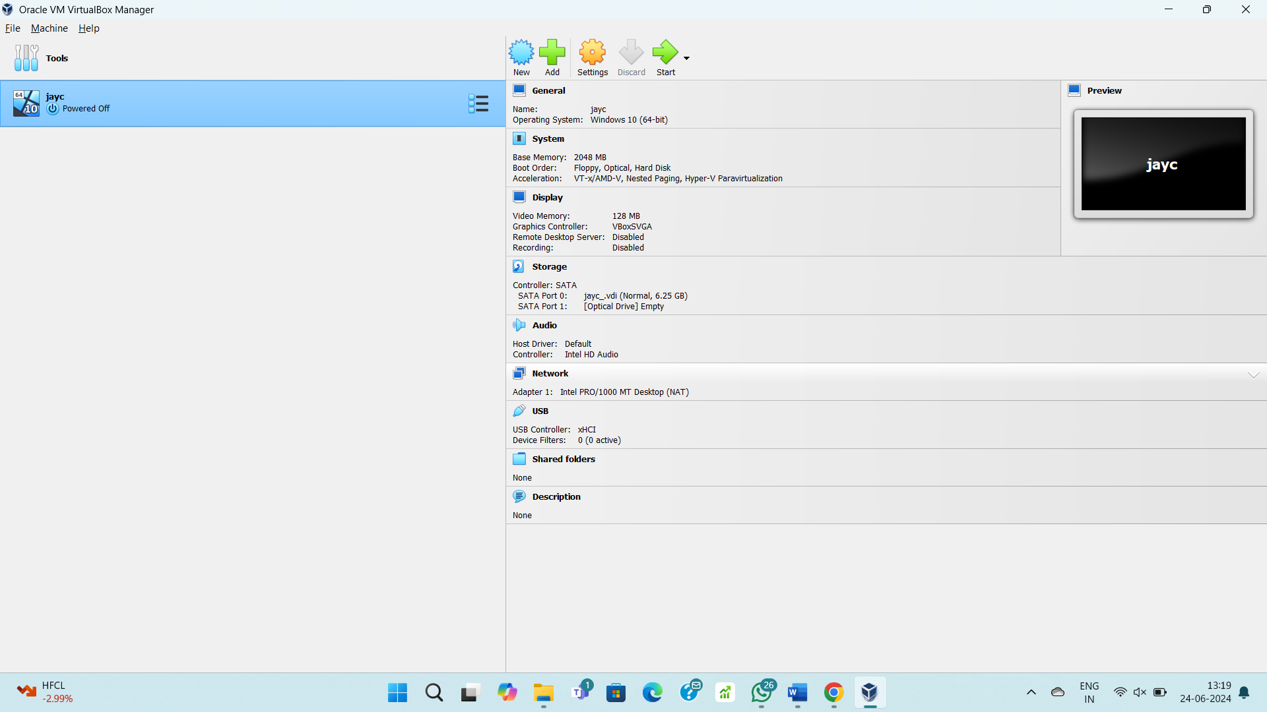

**STEP – 5:**

Clone created with different specs.

